Design Competition Brief
6th IABSE YEC in East Asia
Jointly organized by IABSE National Groups of China, Japan, Korea & Hong Kong SAR
October 29 (Thu) – 31 (Sat), 2026 | Shanghai, China

Project Background
Suzhou Creek is a central waterfront corridor in Shanghai, running through the urban core and connecting to the Huangpu River. Historically an industrial area, it has been transformed in recent years into a vibrant public space with parks, cultural venues, and pedestrian-friendly waterfronts.
The project site is located between Datian Road and Meiyuan Road, where both riverbanks attract significant pedestrian and cycling activities. The area is well connected by public transport and surrounded by mixed urban functions, including residential neighborhoods, cultural facilities, and open spaces.

Design Task and Requirements
The task is to design a pedestrian/bicycle bridge across Suzhou Creek, connecting the following two key nodes:
- North bank: Meiyuan Road × Guangfu Road (upper red point, see Figure 1)
- South bank: Datian Road × South Suzhou Road (lower red point, Figure 1)
The bridge shall provide a safe, convenient, and efficient crossing for both pedestrians and cyclists across Suzhou Creek.
A direct connection between the two points is approximately 132.7 m, which may be challenging to achieve with a single span. As no piers are permitted within the river, alternative alignment strategies may be explored. A perpendicular crossing would reduce the span to approximately 64 m, but both ends are constrained by existing roads and buildings, requiring careful spatial organization and integration with surrounding traffic systems.
The design should address the following requirements:
- Accessibility and circulation:
The bridge shall accommodate both pedestrians and cyclists. The bicycle route shall connect directly between the two intersections, while the pedestrian alignment may be adjusted according to the design proposal. The design should effectively organize pedestrian flow, bicycle flow, and their connections to the surrounding road network.
- Spatial quality and user experience:
The bridge should incorporate viewing platforms or spaces for staying and enjoying the waterfront, enhancing the overall user experience.
- Structural constraints:
The bridge shall cross the river in a single span, with no piers allowed in the waterway. Abutments may be located within the waterfront space (see Figure 2). As the river is fully navigable, a minimum vertical clearance of 6.0 m must be maintained (Figure 2).
- Constructability:
The design shall consider construction feasibility. Bridge components may be transported via the Suzhou Creek waterway or the urban road network. Construction methods should minimize impacts on the environment and existing traffic.
- Innovation and sustainability:
The design is encouraged to adopt innovative structural solutions, as well as sustainable materials and construction techniques.
Figure 1. Project Site and Bridge Connection Points
Figure 2. Typical Cross Section of Suzhou Creek

Technical Specifications
- Design load: 3.5 kN/m²;
- Maximum longitudinal gradient for bicycle lanes: not greater than 3.5%;
- Minimum functional cross-section of the bridge: as shown in Figure 3. The bicycle lane and pedestrian walkway may be designed as either combined or separated, depending on the proposal.
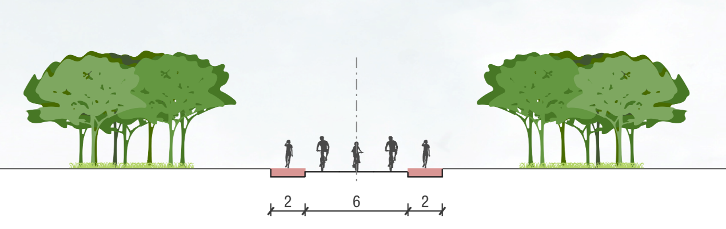
Figure 3. Minimum Required Cross Section of the Bridge

Evaluation Criteria
- Completeness and rationality of the transportation system;
- Structural innovation;
- Bridge aesthetics;
- Constructability of the structure;
- Cost-effectiveness;
- Application of new materials and technologies.

Submission and Presentation Requirements
- Participants shall submit an application form and a design report (A4 size, maximum five pages), including the project title, team members, design concept, and key drawings. The required drawings shall include, at minimum:
  - Site plan and bridge alignment;
  - General layout/elevation of the bridge;
  - Typical cross section(s);
  - Structural concept or key structural details;
  - Perspective views, renderings, or conceptual sketches illustrating the architectural and spatial design.
- The competition focuses on conceptual and preliminary design. Detailed engineering analysis, such as non-linear dynamic analysis or comprehensive finite element modeling, is not required. Participants may use simplified structural analysis and preliminary calculations to demonstrate the feasibility of their proposals.
- A poster session will be arranged in the venue. All posters shall be in A1 size (594 mm × 841 mm) and mounted on display boards. Participants are responsible for printing and bringing their own posters.
- Each team is required to deliver a 10-minute presentation. Please prepare a PPT or PDF file for this purpose.

Eligibility
Participants should be approximately under 40 years of age. Membership in IABSE is not required.
Each team may consist of up to five members.
Teams with international members are encouraged and may receive additional consideration in the evaluation.

Timeline
- Application form submission deadline: September 6, 2026
- Design report submission deadline: October 25, 2026

Awards and Recognition
Outstanding submissions will receive awards and certificates issued by the organizers. Selected projects may also be exhibited during the 6th IABSE Young Engineers Colloquium in East Asia and featured in related event publications or media platforms.

Contact Information
All application forms, design reports, and inquiries should be sent to: iabsechina@tongji.edu.cn

